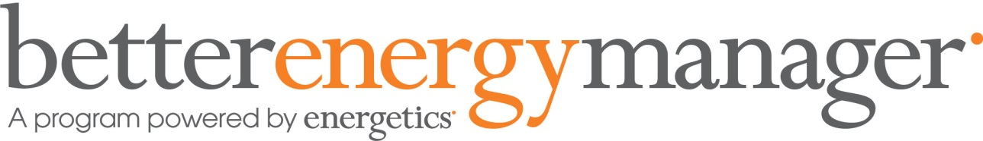

Better Energy Manager Program
Want to save money on your energy bills and understand how to reduce energy usage?
Our Better Energy Manager Program can help you achieve both; by finding the possible retailer and price for you. The program also provides you with energy saving tips and tricks to keep your bills low and reduce consumption.
What our members have to say
"In a small business like ours, every saving counts. We're now getting an extra saving on power, which means that we can employ more people. In turn, we're offering better service and a better standard of work, which is great for us."
James Reid,
Doc's Mega Save Chemist
Newcastle
Iluka Boatshed & Café (Christine Marshall) received her first account after accepting the Better Energy Manager Program Contract that day and she had saved just over $300
Current participating members are achieving savings of $2,000 to $19,000 a year on energy costs and collectively.
All energy quotations are discounts to the published retail rates available to businesses in your area.
Is there a cost to join?
This is an exclusive offer only available for members of the NSW Business Chamber.
There is no cost to be part of the program and there is no obligation to accept the quotation or contract offered to you.
What happens if I am on a contract with my current energy provider?
There may be a small exit fee. It may be worth checking your existing contract to be sure. Depending what region you are in this fee may be covered by the provider, to understand exactly what you are entitled to click join now and complete the form below.
What kinds of energy are covered?
Electricity and Natural Gas. Simply tick the box on the online form.
How do we get such great rates for our members?
Harnessing the power of group buying to obtain great energy rates our partner Energetics has negotiated for members a great discount off published base electricity usage rates.
Energetics will determine the best rate for you based on the negotiated energy rates in your region and you will receive a no obligation quotation and a contract for your approval.
How does my business start saving?
Once agreed, your new contract starts from the next meter read and your discounts will apply for two years.
- Request an offer by completing and submitting an online form. NB. You will need a recent energy bill with you.
- Small energy sites - If your annual usage is estimated to be less than 100,000 mWh. If you fall into this category you will receive an offer and an associated contract to review. If you have provided Energetics with a copy of one of your bills, the Retailer will also provide you with a cost comparison to assist you with your decision making.
- Large energy sites - if you are a large energy site, you will can request customised quotation from one of our retailers or ask Energetics to help you with this process (as a small additional charge).
Post sign up.
- If you decide to accept the offer and the agreement is executed, you will receive an email from Energetics with a log-in and instructions on how to access the full range of benefits available in the Better Energy Manager Program.
- Your new contract will commence following your next meter read detailing the discounted rates depending on your billing cycle, whether it's monthly or quarterly.

Buy better use less
There is more to the Better Energy Manager Program than just discounted electricity rates.
Once your contract is accepted other benefits that you will receive include:
- A competitive residential energy offer available to members and their staff.
- Access to a library of online Checklists and Guides to help increase efficiencies.
- Access to a competitive gas offer.
For Natural Gas, your retail rates are regulated according to how much you consume. Under the program you will receive a discount off the regulated gas rates of up to 16%. You can apply for the gas discount separately and you don’t have to have your electricity under the program to qualify. Gas contracts are 12 or 24 month terms.
About Energetics
Energetics provides specialist advice to business on energy management and carbon reduction strategies.
Consulting to more than half of the ASX top 200, Energetics helps these often complex, multi-site businesses achieve energy cost savings, improvements in efficiency and business productivity, and a more robust approach to managing the risks associated with energy and carbon. Combining technical expertise and commercial insights, Energetics has also worked with all levels of Australian government on policy and program design, implementation and audit.
Find out more on the Energetics website.
Terms and conditions
* The offer is available to NSW Business Chamber member sites classed as SMEs. The discounts apply for 24 months. If you have sites in other states, great rates have also been negotiated. To find out more, please call the Better Energy Manager Program support hotline on 1300 414 245 during business hours.
The Business Savers Program is open to current members of NSW Business Chamber, Hunter Business Chamber, Illawarra Business Chamber, Local Chamber Alliance Program partners and their local chamber members who have opted into the Local Chamber Alliance Partner Program and NSW Business Chamber membership. This offer is not available to Defence Alliance members. This offer is not open to businesses based in the ACT.

