* 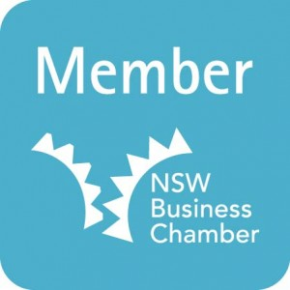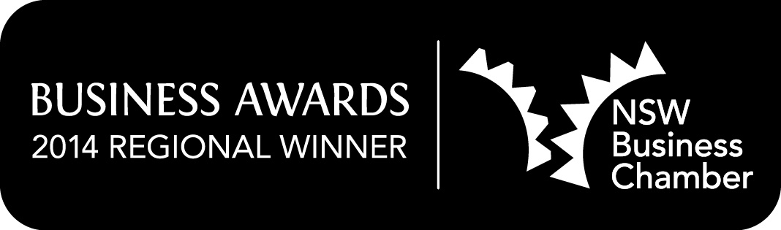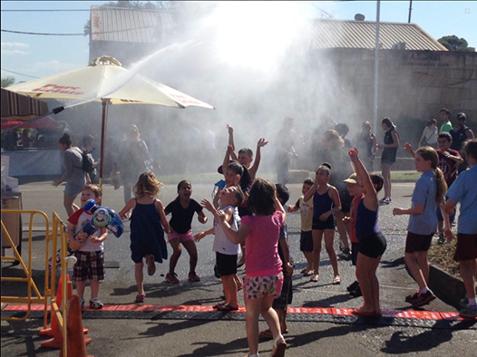

Event committee - Silvana, Michelle, Rocky, Szuszy, Angeline, Julie, Kim, Roy, Moira, Toni, Edward, Grace

Geoff Starr, NSW Business Chamber

Hassan Moussa, RM Gregory Promo Print

John Faker, Mayor Burwood Council

Lucille McKenna, Mayor Ashfield Council

Brian Robson, Mayor Canterbury Council

Marcella Gallace, Photographer / Journalist

Martin Edmunds, MSS Security

Geoff Alcock, MSS Security

Jarad Kelly, Croydon Park Hotel

Tony Mazzotta, Action Electrical

June Donovan, 2RDJ

George Semrany, 7 Day Plumbing

Marco Errichiello, Rich & Oliva

Nick Leontis, Croydon Park McDonalds

Andrew Anderson, Club Burwood

Mick, Club Burwood

Michael Furniss, Croydon Park Ex-Serviceman’s Club

David Spence, Magpies Aussie Rules Club

# Special thank you

Annual

REPORT

2014

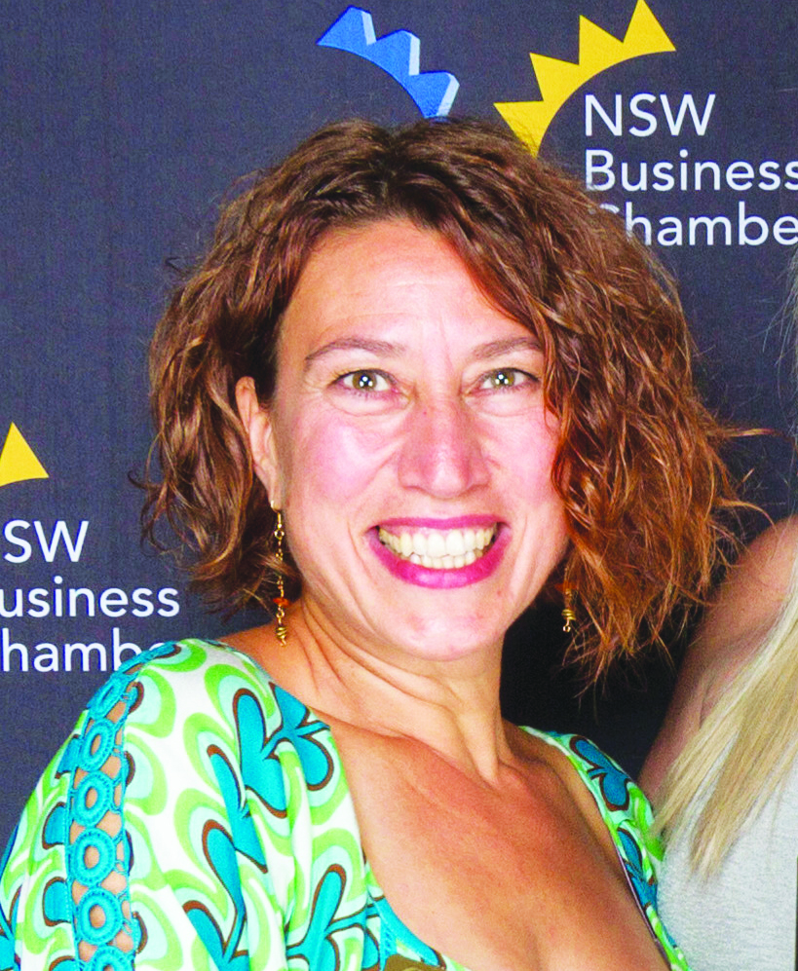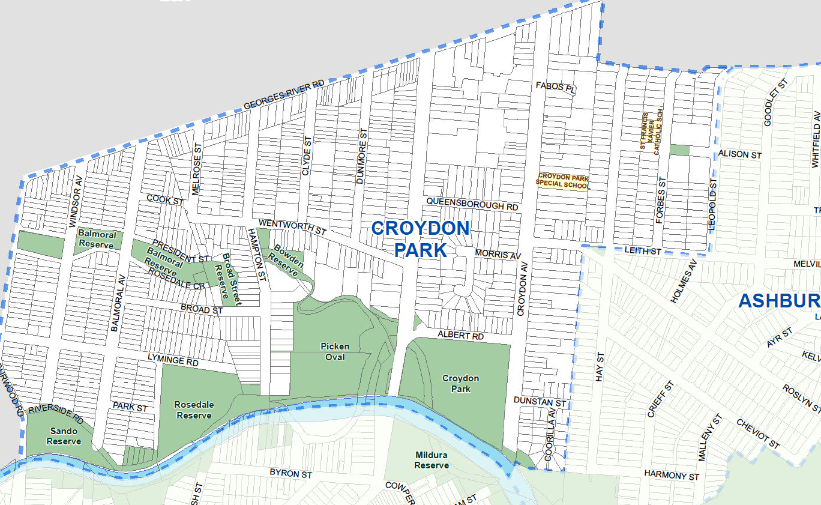

* Welcome
* Acknowledgement of Country
* Guest speaker – Roger Vertannes, Gallop Solutions
* Acceptance of 2013 minutes
* President’s report
* Treasurer’s report
* Election of Board members for 2014/15
* Close

# 7:00 – 8pm: Annual General Meeting

# 6:30 – 7pm: Networking drinks

**Our vision is to be a dynamic centre of support that engages, encourages and empowers local business and community.**

We are proud to belong to the Canterbury, Burwood and Ashfield communities, which are strong, diverse, and resourceful.

We have developed a 2014/15 plan to build on these opportunities, and to outline how we will achieve them, which includes four goals:

1. Shift from a membership-centric approach to focus more on achieving local outcomes.
2. Become an information gateway to help the diverse range of local people and groups in our area connect.
3. Showcase the wide range of local businesses, services, and attractions.
4. Develop clearer guidelines to support Chamber Board members.

Our vision

Our Business Chamber is proud to belong to the Canterbury, Burwood and Ashfield communities, which are strong, diverse, and resourceful.

Agenda

Treasurer’s report

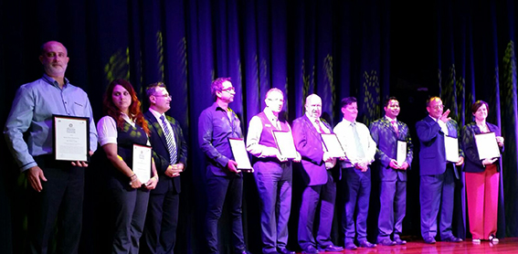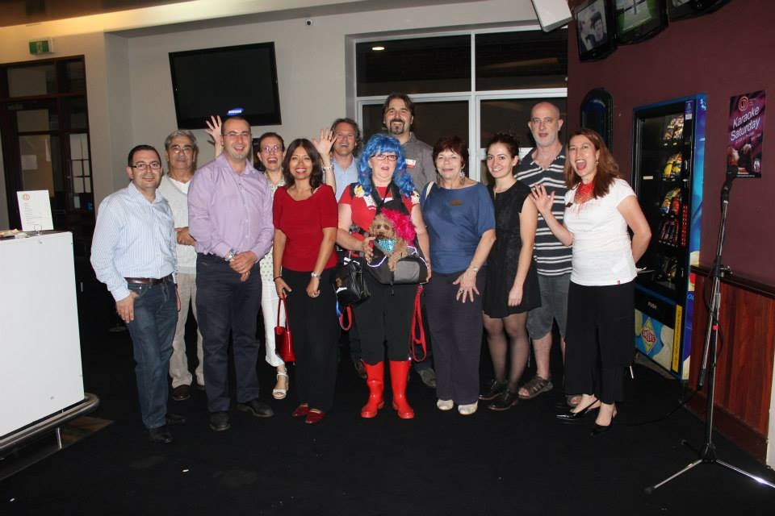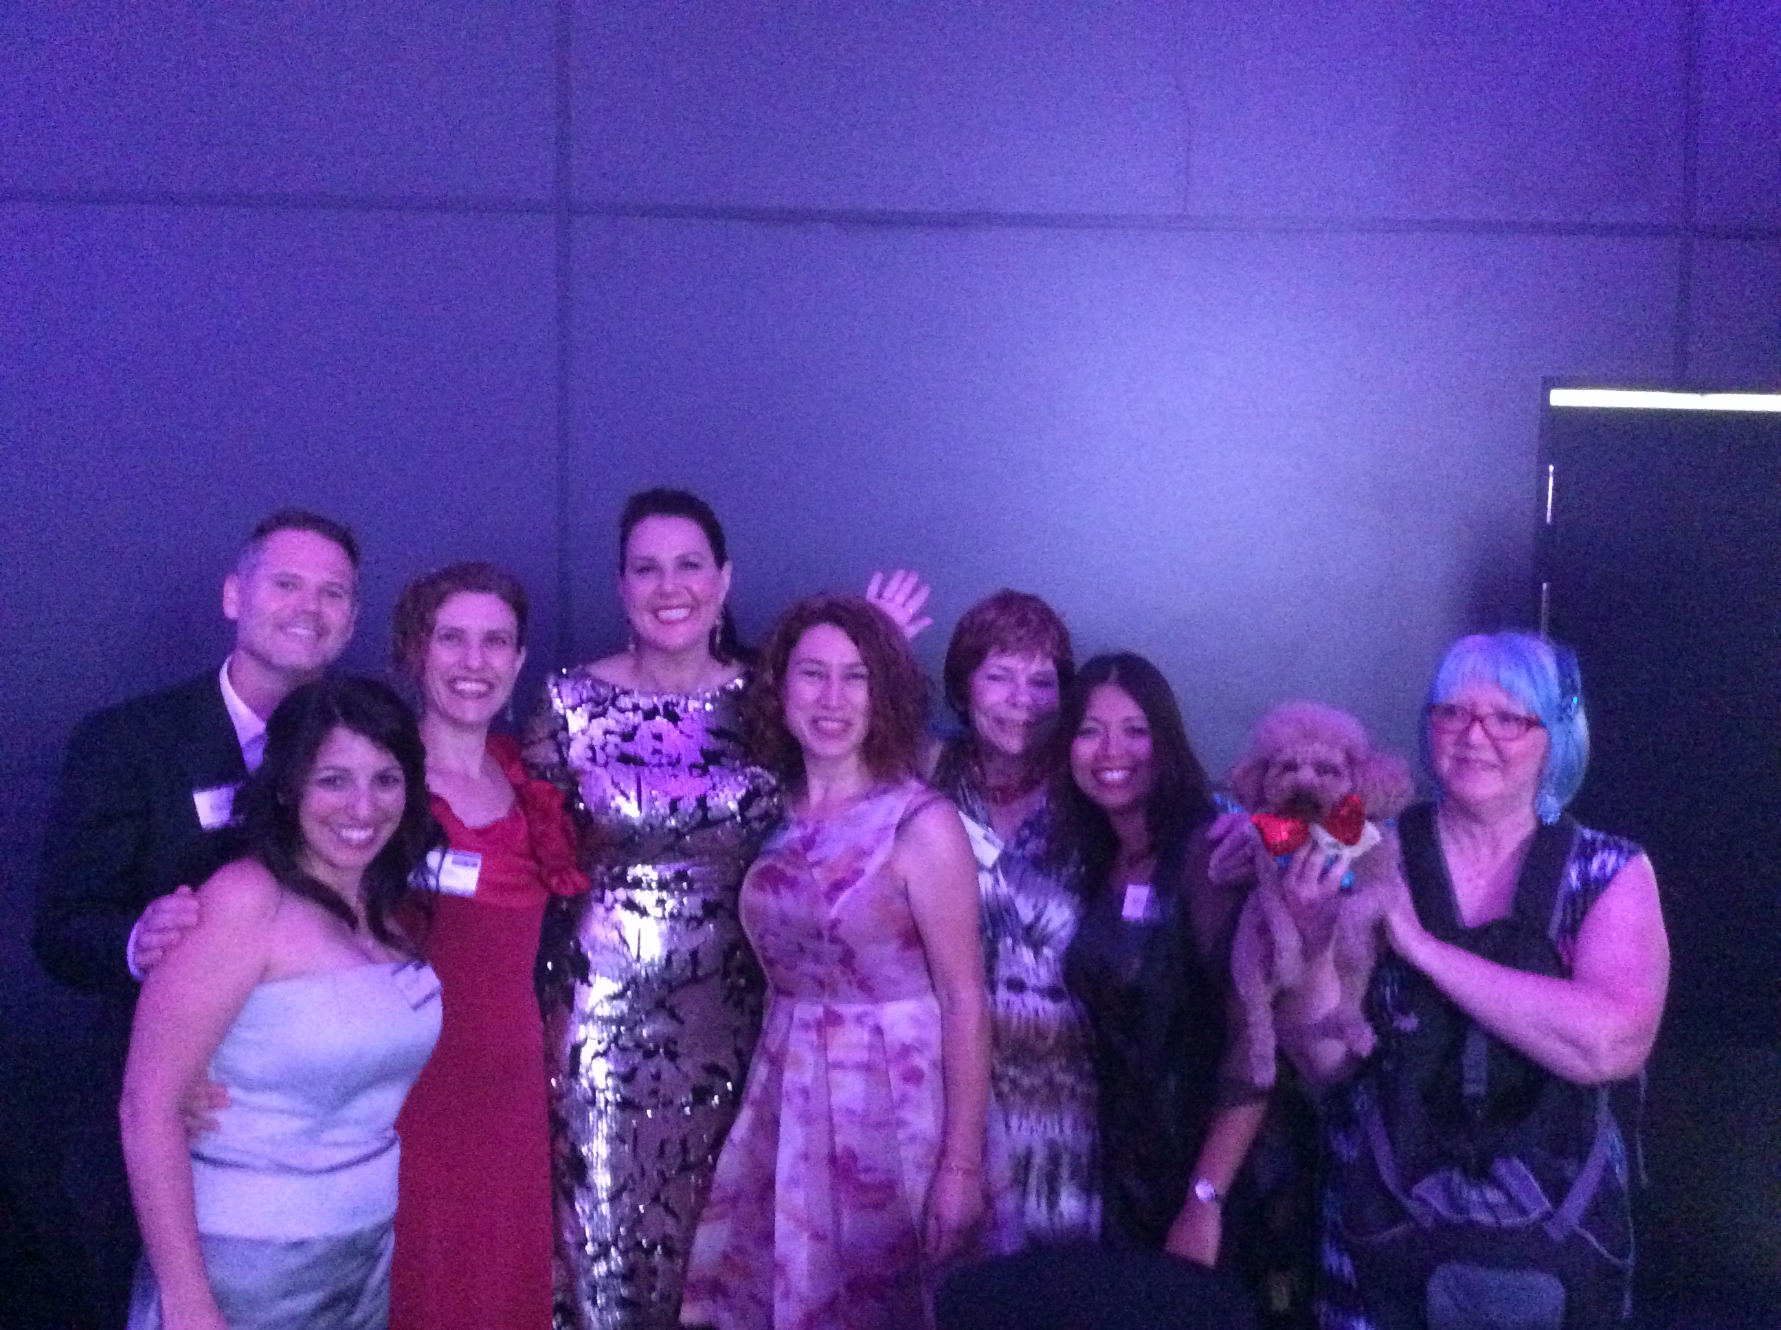

Welcome

Hello, and welcome to our 2014 AGM.

We’ve had an amazing year engaging, empowering, and encouraging local businesses and community, culminating in October with the *Experience Croydon Park Festival*.

I would like to thank the Chamber Board and the Events Committee for their dedication and amazing effort, including the Trivia Night fundraiser.

This year the Croydon Park Business Chamber were announced as the winners of the 2014 South West Local Chamber of Commerce, and we were honoured to attend the State Awards and be amongst the most successful and enterprising businesses in the State – well done to all the State finalists and winners.

We have been fortunate to welcome Geoff Starr as our regional NSW Business Chamber representative. Thank you Geoff for attending our events and for being available to provide us, and our members, with valuable advice and resources.

We are exciting about opportunities in 2015 to further support local business and community, and we look forward to collaborating with you to meet local needs.

Toni Franze, President

2013/14 Board

# 2013 Board

President

Vice President

Secretary

Treasurer

Member

Member

Member

Toni Franze

Moira Verheljien

Brett Martin

Josie Lee

Roy Visser

Michelle Baldock

Angeline Antony